Customer Picking

# ERD for UX process

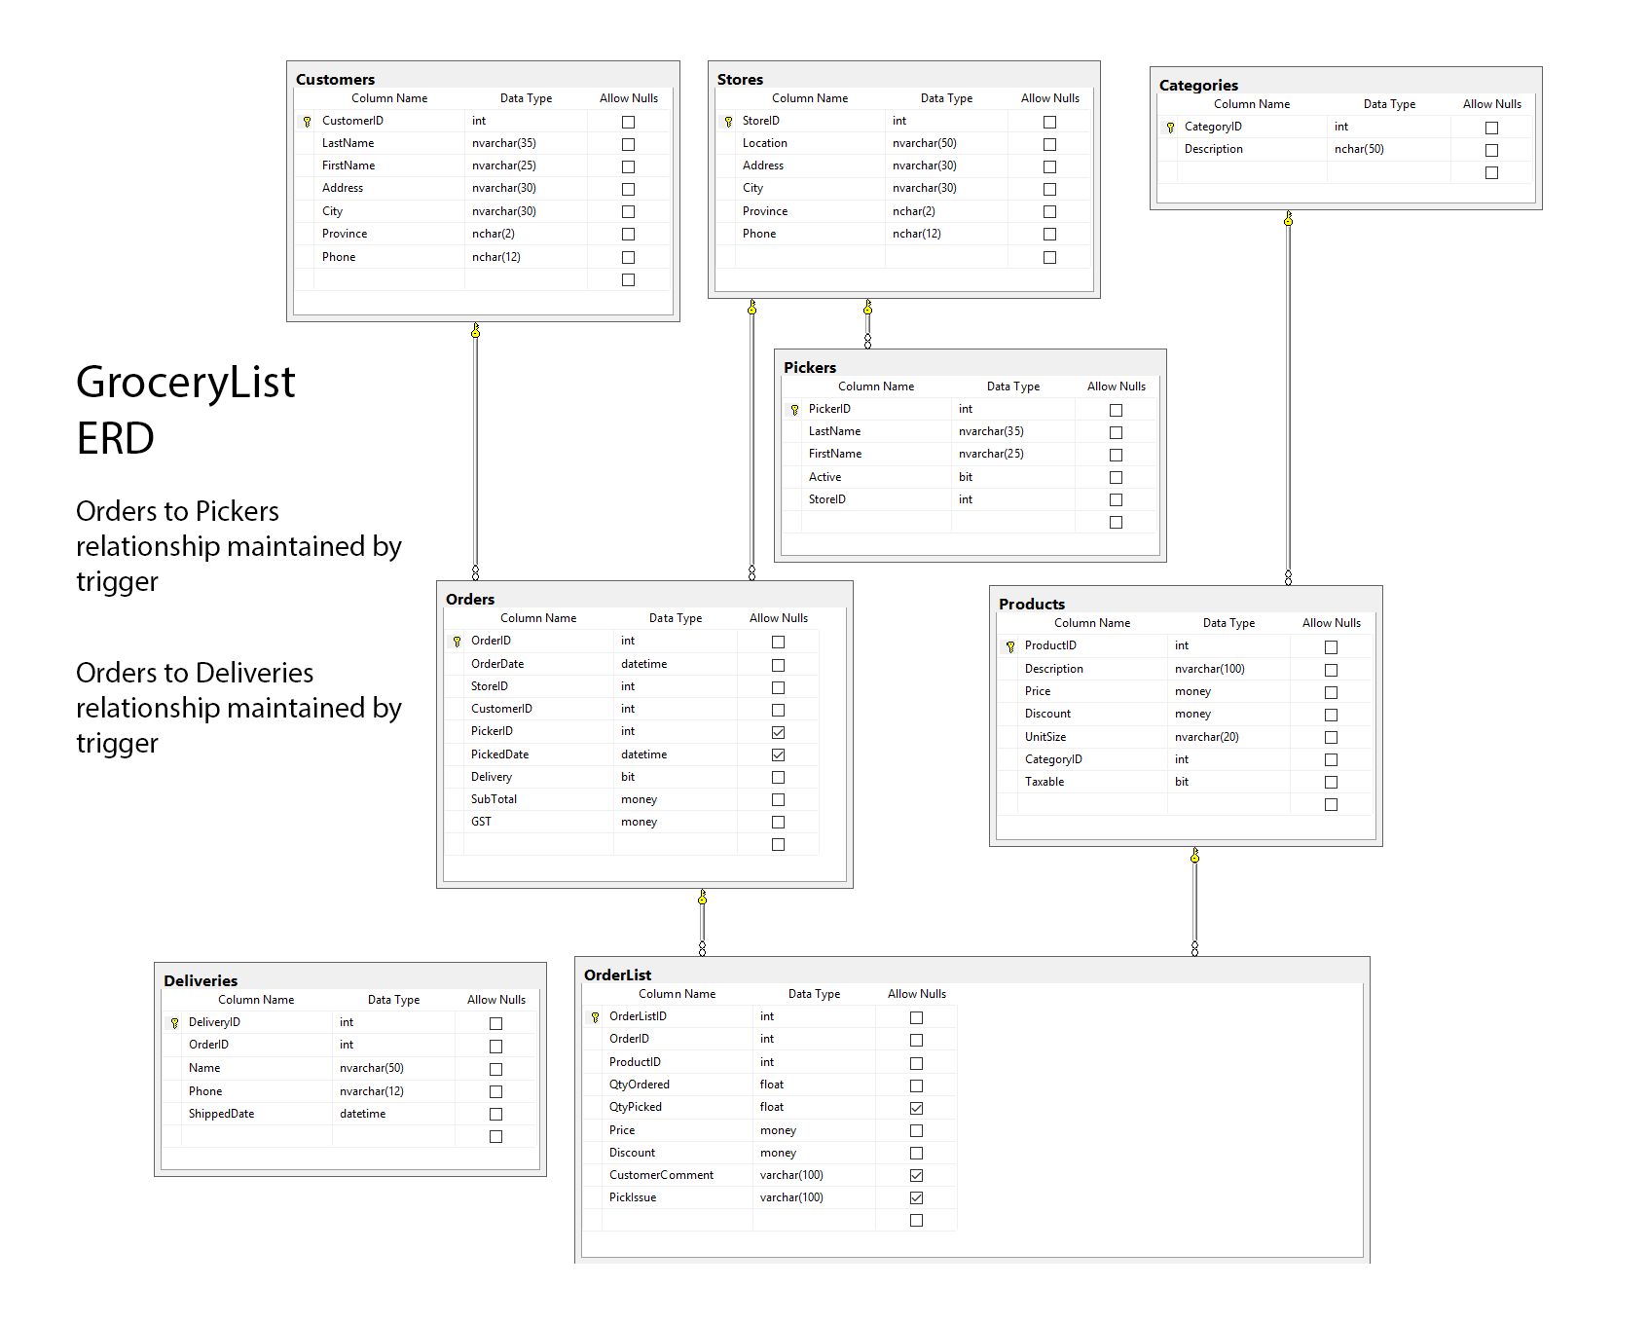

# Possible UX Interface

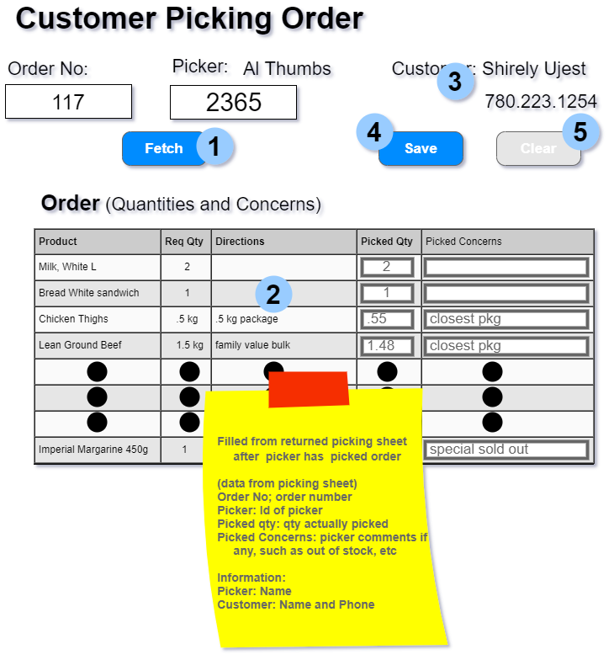

|  |  |  |
| --- | --- | --- |
| **Controls** | | **Events** |
| Fetch (1),  Products (2), ByCustomer(3) | | OnClick / ODS   * Uses selection values of OrderNo and PickerID to retrieve CustomerName and CustomerPhone, moves values to ByCustomer * Bind data to display in products |
| **BBL Class(es) and Method (s)** | | |
| OrderListController | List< OrderListList > OrderProduct_List() (int OrderNo, int PickerID)  Check if the order and the picker exists using the OrderNo and PickerID  Retrieve the list of products for the order by using the supplied OrderNo and PickerID values  Return Product.Description, QtyOrdered, CustomerComment, QtyPicked, PickIssue, OrderlistID | |
| **SQL Table(s): (C,R,U,D)** | | **ViewModels** |
| OrderList (R), Product (R) | | OrderListList |

|  |  |  |
| --- | --- | --- |
| **Controls** | | **Events** |
| Save (4),  Order (2) | | OnClick / ODS   * Collect all PickedQty and PickIssue values in the textboxes in Order (2) * Send to BLL to update OrderList items |
| **BLL Class(es) and Method (s)** | | |
| OrderListController | OrderListUpdate (OrderListList item, int OrderID, int PickerID)  First check the new PickIssue value if it is under 100 characters then check QtyPicked if greater than or equal to zero  Use the parameter values and update the QtyPicked and PickIssue values | |
| **SQL Table(s): (C,R,U,D)** | | **ViewModels** |
| OrderList (U) | | OrderListList |

|  |  |  |
| --- | --- | --- |
| **Controls** | | **Events** |
| Clear (5) ,  Order (2) | | OnClick   * Clear all textboxes for PickedQty and PickIssue in Order (2) |
| **BLL Class(es) and Method (s)** | | |
|  |  | |
| **SQL Table(s): (C,R,U,D)** | | **ViewModels** |
|  | |  |

# ViewModels:

**OrderListList**

* string ProductDescription
* int QtyOrdered
* string CustomerComment
* int QtyPicked
* string PickIssue
* int OrderListID